**Institute of Information Technology & Management**

**External Practical Exam**

**Subject: DBMS Duration: 2 Hrs**

**Set-A**

1. Consider relational database:

Supplier (Supno, sname, supaddress)

Item (Itemno, Iname, stock)

Supp-Item (Supno, Itemno, rate)

Write RDBMS expression for the following

i. List all suppliers from ‘Varanasi’ city who supplies PISTON.

ii. Display all suppliers supply PISTON RINGS

iii. Change supplier names to upper case

2. Implementation of DDL commands of SQL with suitable examples

i. Create table

**CREATE command syntax with column level constraints**

* **Create table employee**

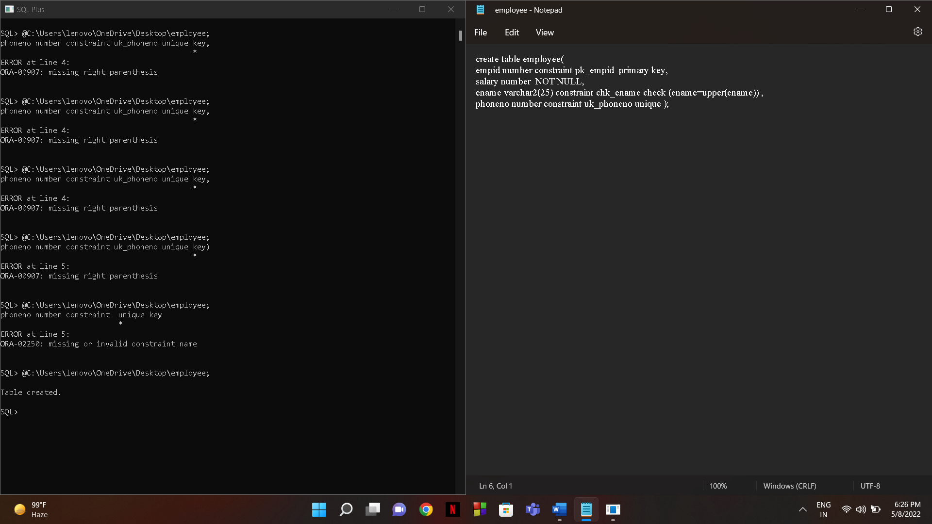

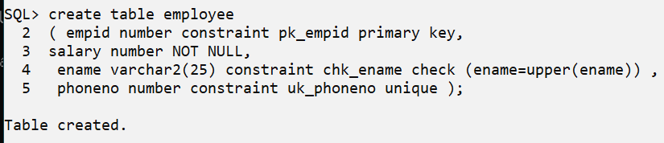OUTPUT

ii. Alter table

1. **ALTER to add column, remove column, add constraint and remove constraint**
   * + **ADD COLUMN COMMAND**

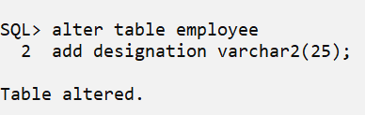

* + - **ADD CONSTRAINT COMMAND**

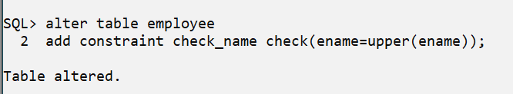

* + - **REMOVE CONSTRAINT COMMAND**

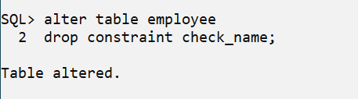

iii. Drop Table

